## RESEARCH PROJECT REPORT

**On**

# “IMPACT OF THE COVID-19 ON THE RECRUITMENT PROCESS OF COMPANIES”

***Project Report submitted in partial fulfillment for the award of the degree of***

**BACHELOR OF BUSINESS**

***Submitted by***

**PRIYANSH CHANDRA**

**19GSOB1010082**

**PUSHKAR KUMAR**

**19GSOB1010020**

**IN**

**BACHELOR OF BUSINESS ADMINISTRATION SCHOOL OF BUSINESS**

**Under the Supervision of Dr. Arvinder Kaur Assistant Professor**



**YEAR (2019-2022)**



# SCHOOL OF BUSINESS

## BONAFIDE CERTIFICATE

Certified that this project report **“IMPACT OF COVID-19 ON THE RECRUITMENT PROCESS OF COMPANIES”** is the bonafide work of **“PRIYANSH CHANDRA (19GSOB1010082) AND PUSHKAR KUMAR (19GSOB1010082)”** who carried out the project work under my supervision.

**SIGNATURE OF DEAN SIGNATURE OF SUPERVISOR**

**APPROVAL SHEET**

# This thesis entitled “IMPACT OF THE COVID-19 ON THE RECRUITMENT

# PROCESS OF COMPANIES” prepared and submitted by PRIYANSH CHANDRA AND PUSHKAR KUMAR.

# in partial fulfillment of the requirements in Research for the Degree of Bachelor of

# Business Administration has been examined and is recommended for approval and

# acceptance.

**Examiners**

**Supervisor (s)**

**Chairman**

**STATEMENT OF PROJECT REPORT PREPARATION**

1. Thesis title: **Impact of the Covid-19 on the recruitment process of companies.**

2. Degree for which the report is submitted: **Bachelor of Business Administration (BBA).**

3. Project Supervisor was referred to for preparing the report.

4. Specifications regarding thesis format have been closely followed.

5. The contents of the thesis have been organized based on the guidelines.

6. The report has been prepared without resorting to plagiarism.

7. All sources used have been cited appropriately.

8. The report has not been submitted elsewhere for a degree.

**(Signature of the Student)**

**Name- PRIYANSH CHANDRA.**

**PUSHKAR KUMAR**

**Roll Number- 19GSOB1010082.**

**19GSOB1010020.**

**Statement of Preparation:**

# ABSTRACT

The impact of COVID 19 on businesses is inevitable, it has hampered everything from the economy to livelihood of businesses and organizations are going through this difficult time. Organizations look for clever solutions by which they can continue operations smoothly. From hiring employees to keep them everything is a big challenge. The recruitment process identifies the vacancy of jobs, invites applications, analyzes the job demands, reviewing the applications, screening, listings, and selects the suitable candidate for the job. In COVID-19, organizations are operating fairway and their workers are working from their homes. In recruitment, electronic - Recruitment or online recruitment uses web-based technology for identifying, evaluating, picking, and onboarding job prospects.

It is a technology that helps a company to online workflows and recruitment tasks to boost productivity, time-to-fill, cut hire costs and improve their organization's overall skills profile. This study address to figure out the impact of Covid-19 Pandemic conclusion in the recruitment process, to explain how E- recruitment is swapping human participation in the recruitment process. The objective of this study is to examine the impact of the Covid-19 Pandemic situation on the Recruitment process that is E -recruitment of the employees working in Information Technology (IT) companies of Noida, Uttar Pradesh. A total number of 100 employees from five different IT companies have been considered for the study. This study is expected to help in the statement of recruitment strategies to align and develop an effective recruitment process to recruit qualifies talent which can work in the competitive environment.

## TABLE OF CONTENTS

|  |  |  |
| --- | --- | --- |
| **SR NO.** | **TITLE** | **Page No.** |
| **1.** | **ABSTRACT** | **v** |
| **2.** | **LIST OF TABLES** | **vii** |
| **3.** | **LIST OF FIGURES** | **viii** |
| **4.** | **INTRODUCTION** | **1** |
| **5.** | **LITERATURE REVIEW** | **4** |
| **6.** | **RESEARCH METHODOLOGY** | **6** |
| **7.** | **DATA ANALYSIS** | **7** |
| **8.** | **DATA INTERPRETATION** | **21** |
| **9.** | **FINDINGS AND CONCLUSION** | **22** |
| **10.** | **APPENDICES** | **23** |
| **11.** | **REFERENCES** | **24** |
| **12.** | **QUESTIONNAIRE** | **25** |

**LIST OF TABLES**

**Table 1:** Job Analysis. . . .. . . . . . . . . . .. . . . . . .. . .. . .. . . .. . . … . .. . . . .

**Table 2:** Distribution of Respondents. . . . . . . . . . . . . .. . . . . .. . . . .. . . . .

**Table 3:**  Technology cannot replace interaction . . . . . . . .. . . .. . . . . . . . .

**Table 4:**  Geographical location of the interview will . . .. . . . . . . . .. .. . .

**Table 5:** Internet connectivity is a basic . . .. . .. . .. . . . . . . . . . . . .. . . . .

**Table 6:** With the help of e-recruitment procedures . . .. . . . .. . . . . .. . . . .

**Table 7:** The e-recruitment speeds up time for . . . . . . . . . . . . . . . . . . . . .

**Table 8:** Regular training is provided by my . . . . . . . . . . . . . . . . . . . . . .

**Table 9:** Biasness in decision-making can be . . . . . . . . . . . .. . . . . . .. . .

**Table10:** Check or Tests scenarios help in. . .. . . . . . .. . . . . . . . .. . . . . . . .

**Table11:** E-recruitment enables recruiters. . .. . . . .. . . . .. . . .. . . .. . … . . .

**Table12:** The e-recruitment test scenarios help in. . . .. . . . . . . . . . . .. . . . .

**Table13:** I am satisfied using an e-recruitment. . . . .. . . . .. . . . . . . . . . .. . .

**Table14:** The e-recruitment software using by. . . . .. . . . .. . . . . . . .. .. . . .

## LIST OF FIGURES

**Figure 1.1:** Technology cannot replace interaction . . . . .. . . .. . . . . . . . . .. . . .

**Figure 2.1:** Geographical location of the interview . . .. . . . . .. . . . . .. . . . . .. . .

**Figure 3.1:** Internet connectivity is a basic issue faced . .. . . .. .. . . . . . .. . . . . .

**Figure 4.1:** With the help of e-recruitment procedures . . .. . . . .. . . . . .. . . .. .. .

**Figure 5.1:** The e-recruitment speeds up time for . . . . . . . . . . . . . . . . . . . . . . .

**Figure 6.1:** Regular training is provided by my . . . . . . . . . . . . . . . . . . . . .. . . .

**Figure 7.1:** Biasness in decision-making can be . . . . . . . . . . . . . . . . . . . . . .

**Figure 8.1:** Check or Tests scenarios that are . . . . . . . . . . . . .. . . . . . . . . .. . . . .

**Figure 9.1:** E-recruitment enables recruiters . . . . . . . . .. . . . . . . . .. . . .. . . . .. . .

**Figure 10.1:** The e-recruitment test scenarios help in. . .. . .. . … . .. . .. . . .. . ..

**Figure 11.1:** I am satisfied using an e-recruitment . . . . . . . . . . . .. . . . . .. . . . . .

**Figure 12.1:** The e-recruitment software using by . . . . . . .. . . . . . . . . . . . . . . .

# INTRODUCTION

In today's changing world, finding the right individual for the appropriate job is nit-picking. Companies rely on qualified resources but finding them is an expensive endeavor. Most enterprise has a conventional hiring process that includes evaluating resumes, group discussions, interviews. According to studies, companies are moving and adopting technology. Without abandoning the idea of going global in social aspects, the recruiting cost can be decreased by having an e-recruitment program. Most Organizations should be focusing on building an online recruitment procedure that allows for the creation of concrete premade profiles.

An institution goal is always the same to reduce costs and automate procedures. According to the google, e-recruitment is the method and process of recruiting personnel utilizing electronic resources, particularly internet. Institution and recruitment agencies have shifted much of their recruitment process and method from traditional to online mode to enhance the speed with which potential candidates are matched with available positions. HR Managers can fill the available positions in a half of the time which was previously achievable by absorbing database technology, online job advertising boards, and search engines.”

Though Covid-19 comes up with many challenges for the institution, recruitment is one of them. Traditional methods used by organizations such as posting the jobs on various platforms may create unemployment and lack of skilled employees for the organization. Selecting and finding the right candidates for the organization is no small task. Corporate as adjusting to adopt technology-aided recruitment techniques and total which can be used remotely and help in ensuring hiring as well as in business continuity caused by the pandemic disruption. Management tend to have data-based and analysis-driven inputs that can be used in recruitment decisions to ensure the availability of experienced candidates.

The e-Recruitment system cut down the pollutants and energy associated with the production, transportation, and usage of paper items. The automatic procedure would save energy in various functions like sending letters by posts, recording the data in hard copy, filing of details, report making, etc. E-Recruitment helps in compressing paperwork used in resumes, advertising, and publishing results. The management should create an easy-to-use and functional online portal to build a tangible online hiring process that can provide a concrete premade profile. The E- recruitment should be well-designed so that it provides the organizations with acceptable professionals for the role, with an emphasis on taking the tests in the Online platform which should focus on Skills tests, Competency tests, Experience sharing, Psychometric tests, and in the end submitting the candidature. Once the profile is submitted to HR, the system should be able to achieve the necessary required data, allowing the HR team to conduct telephonic/online interviews to assess the person's capabilities, followed by a face-to-face interview with the shareholder. Employers can access a larger number of potential employees through e-recruitment. Companies can build up their electronic-recruitment platforms, by using e-recruitment HR software, or by using recruiting agencies that include e-recruitment in their package.

# RECRUITMENT AND COVID-19 PANDEMIC

Recruitment is the process of inviting, finding, choosing, and at last employing the best suitable and qualified candidate and fit him/her in the organization. It is the process by which the management attract and find the employees to fill job openings. Recruitment is defined as a series of activities conducted by an organization to attract the attention of job seekers who possess the skill set which is required by the organization in accomplishing its objectives and goals. Inviting applications, understanding the requirements of jobs available, attracting employees to apply, screening and finally selecting the best candidate placement and induction of the new employee to the organization are all constituents of the recruitment process. Organizations should be able to understand and predict whether the available workforce of the organization would be able to meet the requirements on the quantity and quality of employees required for the achievement of organizational objectives. Also, to find out the difference in the available and required employees should be done to fix the most suitable employees on the job.

|  |  |
| --- | --- |
| **Job Analysis** | |
| **Job Description** | **Job Specification** |
| Job Title | Qualifications |
| Job Location | Experience |
| Job Summary | Training |
| Reporting To | Skills |
| Working Conditions | Responsibilities |
| Machines to be Used | Emotional Characteristics |
| Hazards | Sensory Demands |

***Figure1: Job Analysis***

## JOB ANALYSIS

An investigation of the work on the Internet is an easy alternative. Job analysis is the process of understanding and revealing the duties, roles, and responsibilities of a given selected job in the organization. In the past few years, there has been a considerable shift and increase in the usage of online methods for doing job analysis surveys, and most organizations prefer to use online methods to collect this data.

## JOB DESCRIPTION

The rise of information automation has altered job description management and other elements of talent management.HR departments have often maintained their printed job descriptions on computers or corporate servers either in cabinet filings or in word descriptions. There are now many organizations that offer cloud-based personnel management systems to corporations that enable the human resource department to effortlessly store and file HR information, association with other departments, and access different files with the help of the internet from any device.

## JOB SPECIFICATION

Job specification is a written document in which the alignment to do a job are being stored like educational qualification, required skill set, years of experience, physical compatibility if required, affecting stability, soft skills, and any other skills to do a selected job.

Businesses are looking for strategies to be productive in the face of massive hurdles as COVID- 19 sweeps the nation and the world. Handling employee procedures, growing or lowering headcount, and sustaining workloads have become a distant operation for many firms as they strive to protect their employees, customers, and the general public. The contagious has shifted a significant portion of the workforce in unexpected ways. Distant employment has become the new norm for firms that can implement appropriate social distancing techniques. Employees are modifying living rooms into offices while juggling children and personal duties. Businesses must make challenging decisions about how to adapt to and survive this massive transformation and recruiting practices have shifted overnight.

Today, program as service suppliers are part of the job description management business, including those incorporated into the recruitment tools of a comprehensive, integrated talent management series and self- sustaining solutions. Results such as Halogen's Job Description Builder have made it possible to integrate with broader talent management activities of recruitment and job description management and authorized HR departments of any type of company. It helps in handling and verifying the job descriptions for all interested parties, such as employees, managers, recruiters, lawyers.

## LITERATURE REVIEW

Abia, M., & Brown, I. (2020) reviewed that e-recruitment is known by many other names, like internet recruitment, online recruiting, web recruitment. E-recruitment as compared to traditional recruitment use information technology and software to manage the recruitment process of the organization. A recruiting model that presents the recruitment process includes the activities like setting the objectives of recruitment, strategy designing, conducting the recruitment activity, and assessing recruitment output. Recruiters fight for the best-fit applicants (job seekers which are suitable and perfect fit for the available job), whereas, job seekers compete for jobs to get selected; this motivates both the organization and candidate to adopt information technology fast to alleviate some of the challenges in the recruitment efforts. This study reviewed five concepts of e-recruitment that emerged from extant literature, these are e-recruitment as a technology tool, system, process, service, and proxy. It also concluded the problem of diversity in the organization to understand the concept of e-recruitment, which goes unnoticed in the stored literature, and advocated that recognizing and labeling the many conceptualizations of e-recruitment can be part of the articulation of diversity. Simón, C., & Esteves, J. (2015) concluded that substantial forces of institutions may induce firms to choose the features of the recruitment websites of the organization are based on copying and feature the colleagues in their reference, networks, and groups. In the other research studies of the IT industry, e-recruitment functions that the HR personnel may utilize to tailor the available application to as per their requirements and cost- benefit criteria. IT sector examination of digital business strategies by emphasizing the significance of understanding the external environment and its role in forming the digital business strategy. To summarize, electronic recruitment has the scope to become a significant tool and method for employers and HR professionals in seeking and identifying the top people while reducing expenses occurred with the screening of worldwide candidates. E-recruitment has obvious benefits for any organization, it also creates several obstacles for businesses. Ehrhart *et al.,*(2012) The study on attracting and recruiting is both conceptually and practically useful because the job market is flooded with Web-savvy applicants who frequently visit various websites as their first point of contact with a company. It is crucial to examine the contributions made by the website so that businesses can use it to manage the available resources and attract the best valuable human resources. Given the prominence of this recruitment strategy in companies and the need to balance its potential and risks and also suggested that employee- organization fit should be there to achieve the organizational objective. It also helps in mediating the relationship between work-life balance and enhancing the usability of the website. Organizations should plan for the implications and opportunities of attracting a huge number of potential applicants, and to provide feedback or other important information that could encourage and helps in the better and more accurate selection of human capital through the e- recruitment process. Kucherov, D., & Tsybova, V. (2021) presented that the e-recruitment methods which include internet- based and internal technology-enabled solutions, are to be used in the overall context of human resource management (HRM) digitalization. E-recruitment methods are associated with the favorable outcome. However, e-recruitment utilization does not serve as a bridge between e-recruitment techniques and outcomes. E- recruitment aid not only in lowering the cost of advertisements and selection procedures but also in eliminating paperwork. Hot skill alerts can be enabled to allow organizations to be notified when a candidate

who meets the criteria for future requirements registers. People looking for a job can browse for and apply 24*7. Recruitment agencies, which can cost thousands of pounds, can also be avoided to reap the true economicals benefits of internet recruitment.

Bhupendra, S.H., & Swati, G. (2015). The strategy of hiring the best candidates and encouraging them to investigate job opportunities are defined. The organization itself can recruit, or by outsourcing it to an external agency. On the other hand, it is difficult to determine the most efficient recruitment source and it is situational and has its pros and cons.

Adetunji, O.J., & Ogbonna, I.G. (2013) Recruitment has a long history, starting from prehistoric times because individuals tend to consume the services of others when they cannot do that alone. Adeosun, O. T., & OHIANI, A. S. (2020) presented that organizations can use salary, brand recognition, referral, and job stability as key variables in attracting and recruiting great people. In addition, digitalization is a major approach for attracting, recruiting, and selecting the most eligible employees. Using social media, traditional media, taking interviews online, as well as physical interviews have been shown to aid in the selection of top personnel. Gignac *et al.,* (2021) Studied the influence of COVID-19 on health, money, and organizational support. Human beings with the challenges of physical and mental health expressed more fears and less assistance as compared to other groups during the early stages of the COVID-19 epidemic, as per the findings. The findings also highlighted the significance of job conditions to understand COVID-19, as well as the necessity to evaluate disparities in the conditions of COVID-19 perceptions and understand how work impacts views and can contribute to disparities that may occur as a result of a pandemic. Furthermore, the significance of working circumstances is not restricted to COVID-19. It merits additional research attention in the future and emphasizes the significance of developing more inclusive work opportunities for people with the challenges of physical and mental health. Feldman, D. C., & Klaas, B. S (2002) Concluded that in the recruitment process both recruiter and job seeker can maintain their anonymity. Organizations can search for potential candidates and their CV without advertising vacancies, or they can also promote the vacancies without making their names out. Additionally, job searchers can submit their CVs with the help of the Internet while maintaining the secrecy of their details like their names and details of employment. Al-Zagheer, H., & Barakat, S. (2021) Investigated and introduces the concept of electronic recruitment, as well as its benefits for both businesses and job seekers. Some of the advantages of internet recruitment include: Lowering the organization's costs. Moreover, generating information about a job online is less expensive than advertising it in the newspapers, there are no mediators. Also, the time taken in the recruitment is reduced. E-recruitment facilitates and helps in hiring the right candidate with the optimal skills which improves the efficiency of the recruitment process and also enhances the access to 24*7 to an ample amount of online resumes for both applicants and organizations. E-recruitment has its own set of advantages and disadvantages, some of which are like screening and verifying the skills which consume lots of time. B. Low internet speed or lack of internet access or lack of awareness is also a flaw. C. Companies cannot rely solely on internet recruitment strategies D.In India, both the interviewer and interviewee prefer to connect in person rather than over email.

## RESEARCH GAP

An analysis of the existing literature on this topic suggests that, to date, there is a lot of research done in the area of recruitment, traditional recruitment, methods of recruitment, and the role of technology. This research paper is an attempt to show the impact of the Covid-19 pandemic situation on the recruitment process of IT Companies of the Noida Region and also evaluate the perception of employees towards it.

## RESEARCH OBJECTIVES

1. To examine the impact of the Covid-19 pandemic situation on the recruitment process.
2. To evaluate the influence of e-recruitment on IT company employees.

# RESEARCH METHODOLOGY

## RESEARCH DESIGN

A quantitative method has been used in the study, a questionnaire was prepared and distributed to IT Companies in Noida Region. There are two separate parts to the questionnaire, the first part of the questionnaire represented and focused on the first objective to examine the impact of the Covid19 pandemic situation on the recruitment process. The second part of the questionnaire focuses on the influences of e-recruitment on IT company employees.

## SAMPLING DESIGN

For the survey, the IT companies of the Noida Region were considered and its employees filled the survey form. MS-Excel Version 2010 has been used as the statistical analysis tool whereas the descriptive statistics were calculated and used for the interpretation of findings. The selected population of this study is 100 working employees of IT companies.

## DATA COLLECTION

Data for this study was collected through a Multi-Factor Questionnaire (MFQ) distributed to employees working in the Human Resource Department in Information Technology companies of the Noida Region. The Responses were taken on the Five Point Liker Scale for data analysis and interpretation. The collected data was analyzed using the T-test Hypothesis (One-Tailed Test).

## HYPOTHESIS FOR THE STUDY

**Statement 1:** To examine the impact of the Covid-19 pandemic situation on the recruitment process. Where **H0**= There is no significant impact of the Covid-19 pandemic situation on the recruitment process. **H1** = There is a significant impact of the Covid-19 pandemic situation on the recruitment process.

**Statement 2:** To evaluate the influence of e-recruitment on IT company employees. Where **H0**= There is no significant influence of e-recruitment on IT company employees. **H1** = There is a significant influence of e-recruitment on IT company employees.

## DATA ANALYSIS AND INTERPRETATION

**Table 1:** Distribution of Respondents.

|  |  |  |
| --- | --- | --- |
| **Based on** | **Respondents** | **Percentage (%)** |
| **Gender** | Female | 59 |
| Male | 41 |
| **Departments** | Human Resource | 47 |
| Information Technology | 53 |

**Statements for Research Objective 1:** To examine the impact of the Covid19 Pandemic situation on the recruitment process.

**Table 2: Response to the statement –** Technology cannot replace interaction between human beings.

|  |  |  |
| --- | --- | --- |
| **Serial No.** | **Response** | **Percentage (%)** |
| **1** | Strongly Agree | 27 |
| **2** | Agree | 15 |
| **3** | Neutral | 14 |
| **4.** | Disagree | 12 |
| **5.** | Strongly Disagree | 32 |

**Figure 2: Response to the statement –**Technology cannot replace interaction between human beings.

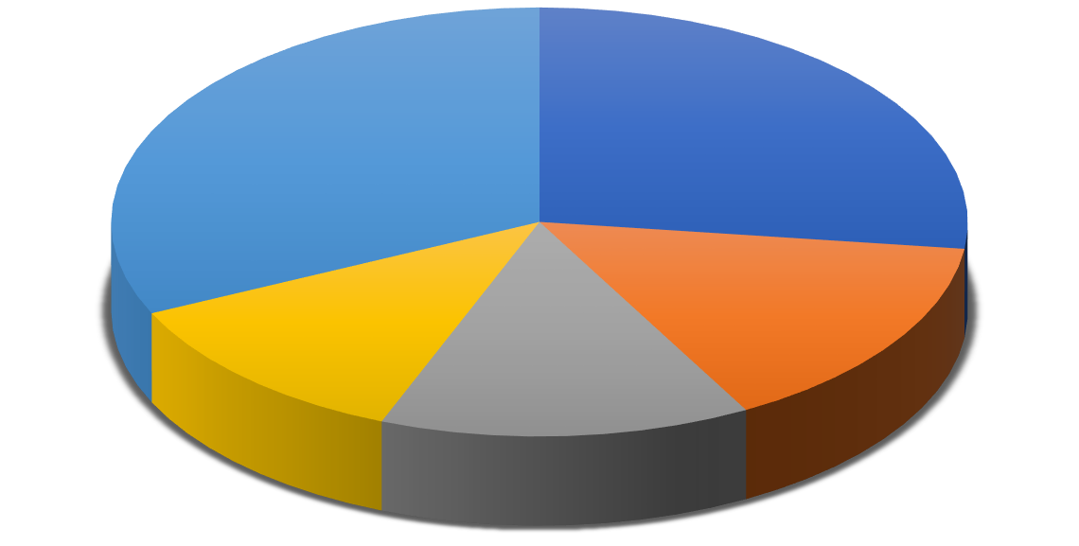

32%

27%

12%

15%

14%

Strongly Agree Agree Neutral Disagree Strongly Disagree

**Table 3: Response to the statement –** Geographical location of the interviewee will not be a hurdle for taking interviews via e-recruitment.

|  |  |  |
| --- | --- | --- |
| **Serial No.** | **Response** | **Percentage (%)** |
| **1** | Strongly Agree | 23 |
| **2** | Agree | 27 |
| **3** | Neutral | 8 |
| **4.** | Disagree | 22 |
| **5.** | Strongly Disagree | 20 |

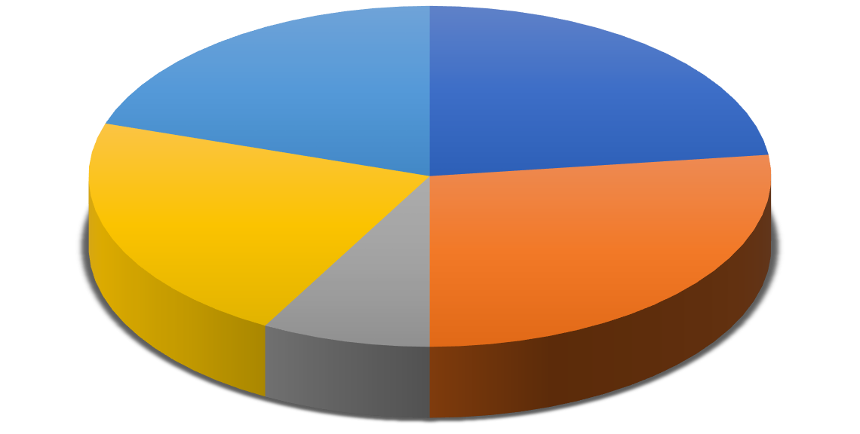

20%

23%

22%

27%

8%

Strongly Agree Agree Neutral Disagree Strongly Disagree

**Figure 3: Response to the statement –** Geographical location of the interviewee will not be a hurdle for taking interviews via e-recruitment.

**Table 4: Response to the statement –** Internet connectivity is a basic issue faced by the interviewer during the e-recruitment procedure.

|  |  |  |
| --- | --- | --- |
| **Serial No.** | **Response** | **Percentage (%)** |
| **1** | Strongly Agree | 31 |
| **2** | Agree | 27 |
| **3** | Neutral | 11 |
| **4.** | Disagree | 13 |
| **5.** | Strongly Disagree | 18 |

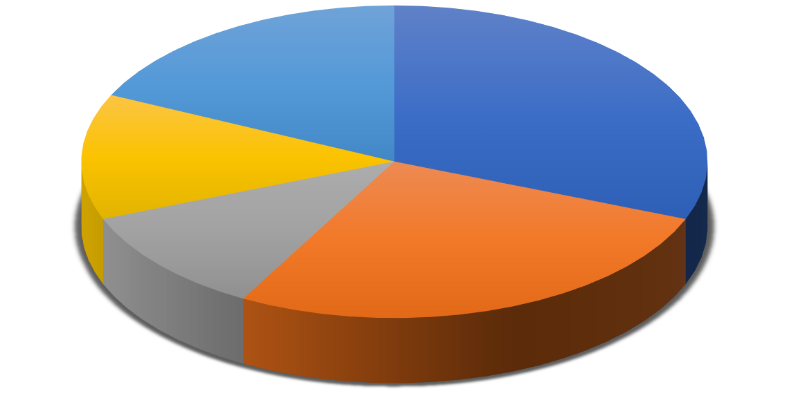

18%

31%

13%

11%

27%

Strongly Agree Agree Neutral Disagree Strongly Disagree

**Figure 4: Response to the statement –** Internet connectivity is a basic issue faced by the interviewer during the e-recruitment procedure.

**Table 5: Response to the statement –** With the help of e-recruitment procedures, the workflow of the HR department smoothens.

|  |  |  |
| --- | --- | --- |
| **Serial No.** | **Response** | **Percentage (%)** |
| **1** | Strongly Agree | 21 |
| **2** | Agree | 29 |
| **3** | Neutral | 24 |
| **4.** | Disagree | 16 |
| **5.** | Strongly Disagree | 10 |

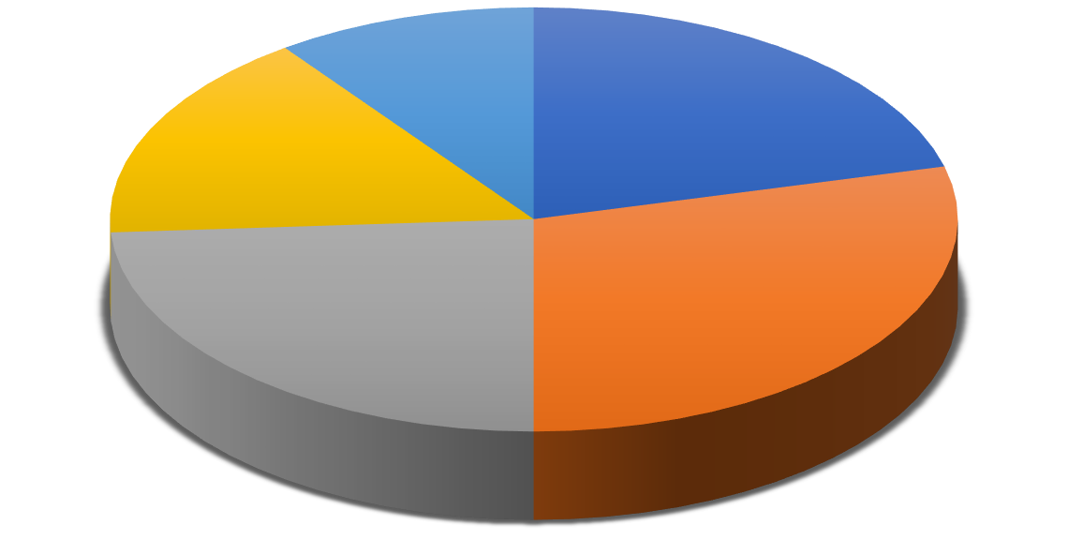

10%

21%

16%

24%

29%

Strongly Agree Agree Neutral Disagree Strongly Disagree

**Figure 5: Response to the statement** – With the help of e-recruitment procedures, the workflow of the HR department smoothens.

**Table 6: Response to the statement –** The e-recruitment speeds up time for completion and improves the company's overall talent profile.

|  |  |  |
| --- | --- | --- |
| **Serial No.** | **Response** | **Percentage (%)** |
| **1** | Strongly Agree | 24 |
| **2** | Agree | 16 |
| **3** | Neutral | 22 |
| **4.** | Disagree | 18 |
| **5.** | Strongly Disagree | 20 |



20%

24%

18%

16%

22%

Strongly Agree Agree Neutral Disagree Strongly Disagree

**Figure 6: Response to the statement –** The e-recruitment speeds up time for completion and improves the company's overall talent profile.

**Table 7: Response to the statement –** Regular training is provided by my organization for the application of the e-recruitment process.

|  |  |  |
| --- | --- | --- |
| **Serial No.** | **Response** | **Percentage (%)** |
| **1** | Strongly Agree | 23 |
| **2** | Agree | 37 |
| **3** | Neutral | 11 |
| **4.** | Disagree | 15 |
| **5.** | Strongly Disagree | 14 |

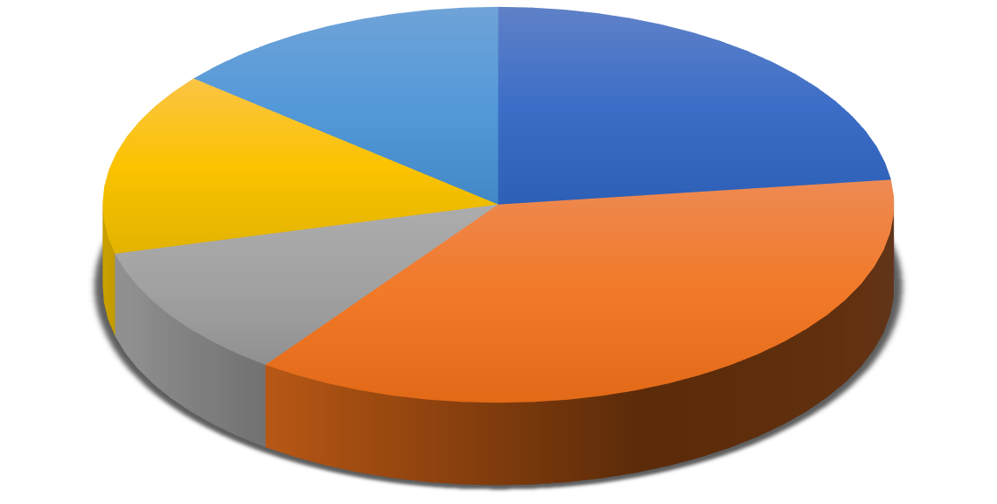

14%

23%

15%

11%

37%

Strongly Agree Agree Neutral Disagree Strongly Disagree

**Figure 7: Response to the statement –** Regular training is provided by my organization for the application of the e-recruitment process.

**Statements For Research Objectives 2:** To evaluate the influence of e-recruitment on working employees of IT Companies.

**Table 8: Response to the statement –** Biasness in decision-making can be avoided by e- recruiting procedures during the recruitment process.

|  |  |  |
| --- | --- | --- |
| **Serial No.** | **Response** | **Percentage (%)** |
| **1** | Strongly Agree | 37 |
| **2** | Agree | 15 |
| **3** | Neutral | 14 |
| **4.** | Disagree | 12 |
| **5.** | Strongly Disagree | 22 |

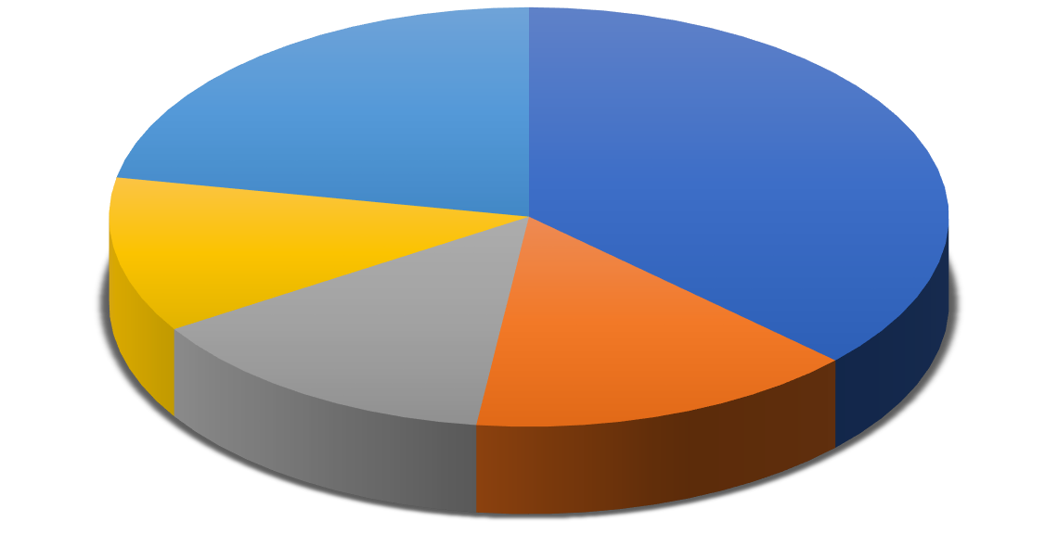

22%

37%

12%

14%

15%

Strongly Agree Agree Neutral Disagree Strongly Disagree

**Figure 8: Response to the statement –** Biasness in decision-making can be avoided by e- recruiting procedures during the recruitment process.

**Table 9: Response to the statement –** Check or Tests scenarios that are prone to human errors are avoided with the e-recruitment process.

|  |  |  |
| --- | --- | --- |
| **Serial No.** | **Response** | **Percentage (%)** |
| **1** | Strongly Agree | 31 |
| **2** | Agree | 23 |
| **3** | Neutral | 12 |
| **4.** | Disagree | 18 |
| **5.** | Strongly Disagree | 16 |

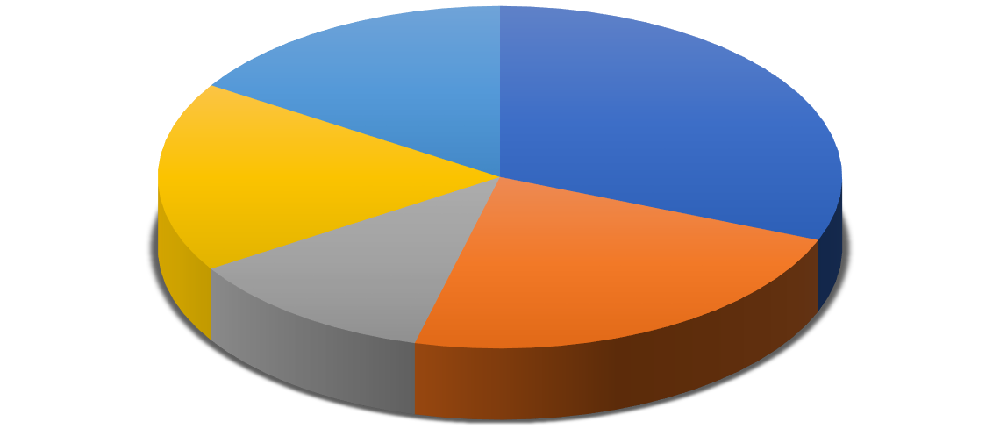

**Percentage**

16%

31%

18%

12%

23%

Strongly Agree Agree Neutral Disagree Strongly Disagree

**Figure 9: Response to the statement –** Check or Tests scenarios that are prone to human errors are avoided with the e-recruitment process.

**Table 10: Response to the statement –** E-recruitment enables recruiters to enhance their productivity.

|  |  |  |
| --- | --- | --- |
| **Serial No.** | **Response** | **Percentage (%)** |
| **1** | Strongly Agree | 23 |
| **2** | Agree | 27 |
| **3** | Neutral | 2 |
| **4.** | Disagree | 27 |
| **5.** | Strongly Disagree | 21 |

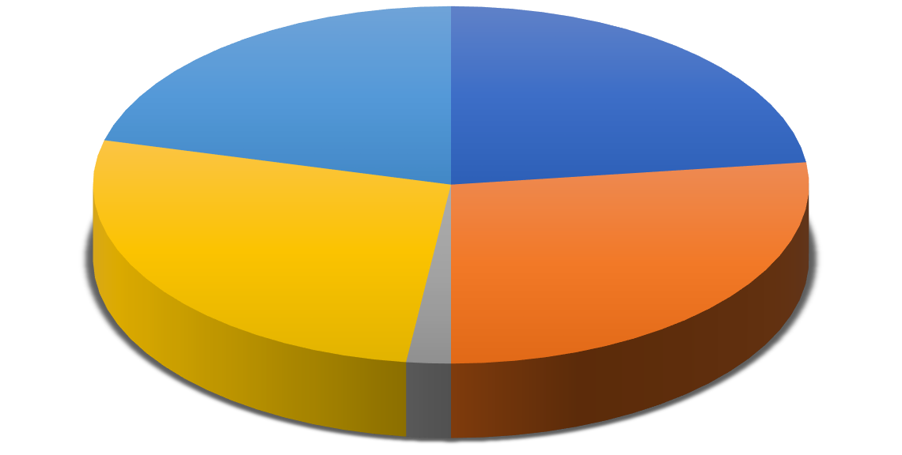

21%

23%

27%

27%

2%

Strongly Agree Agree Neutral Disagree Strongly Disagree

**Figure 10: Response to the statement –** E-recruitment enables recruiters to enhance their productivity.

**Table 11: Response to the statement –** The e-recruitment test scenarios help in achieving the speed of results and minimizing human errors.

|  |  |  |
| --- | --- | --- |
| **Serial No.** | **Response** | **Percentage (%)** |
| **1** | Strongly Agree | 17 |
| **2** | Agree | 34 |
| **3** | Neutral | 7 |
| **4.** | Disagree | 17 |
| **5.** | Strongly Disagree | 25 |

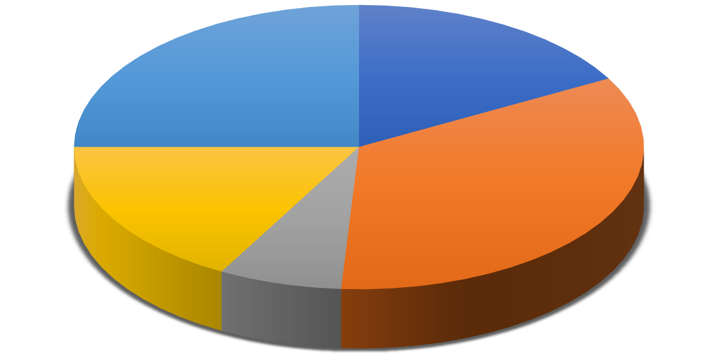

25%

17%

17%

34%

7%

Strongly Agree Agree Neutral Disagree Strongly Disagree

**Figure 11: Response to the statement –** The e-recruitment test scenarios help in achieving the speed of results and minimizing human errors.

**Table 12: Response to the statement –** I am satisfied using an e-recruitment procedure of my organization.

|  |  |  |
| --- | --- | --- |
| **Serial No.** | **Response** | **Percentage (%)** |
| **1** | Strongly Agree | 41 |
| **2** | Agree | 11 |
| **3** | Neutral | 5 |
| **4.** | Disagree | 19 |
| **5.** | Strongly Disagree | 24 |

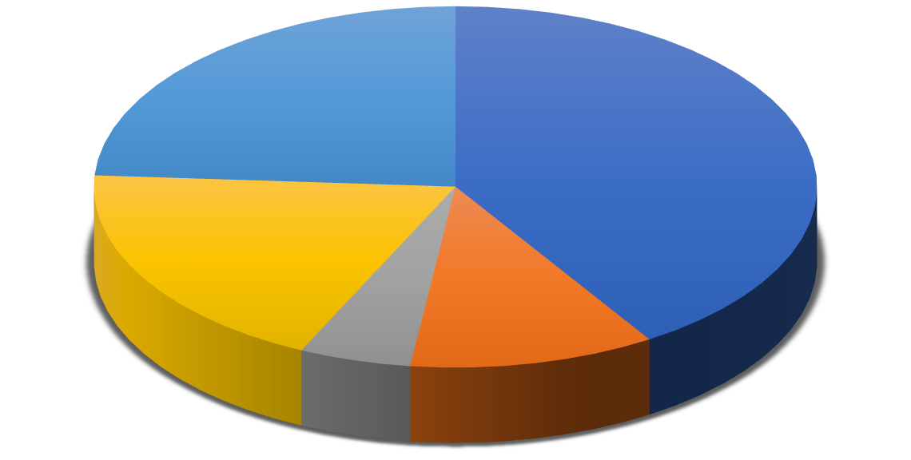

24%

41%

19%

5%

11%

Strongly Agree Agree Neutral Disagree Strongly Disagree

**Figure 12: Response to the statement –** I am satisfied using an e-recruitment procedure of my organization.

**Table 13: Response to the statement –** The e-recruitment software using by your organization is User-friendly.

|  |  |  |
| --- | --- | --- |
| **Serial No.** | **Response** | **Percentage (%)** |
| **1** | Strongly Agree | 29 |
| **2** | Agree | 32 |
| **3** | Neutral | 5 |
| **4.** | Disagree | 24 |
| **5.** | Strongly Disagree | 10 |

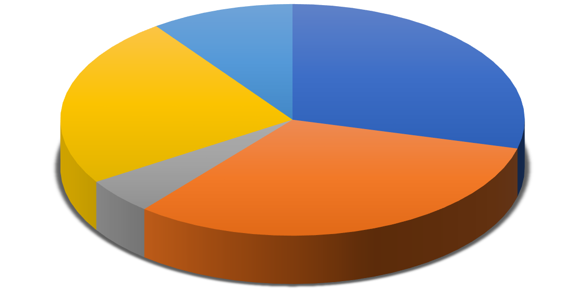

10%

29%

24%

5%

32%

Strongly Agree Agree Neutral Disagree Strongly Disagree

**Figure 13: Response to the statement –** The e-recruitment software using by your organization is User- friendly.

**Table 14:** Scaling based on the Five Point Liker Scale to examine the impact of the Covid19 pandemic situation on the recruitment process.

|  |  |  |  |  |  |  |
| --- | --- | --- | --- | --- | --- | --- |
| **S No.** | **Strongly Agree** | **Agree** | **Neutral** | **Disagree** | **Strongly Disagree** | **Avera**  **ge** |
| **1** | 27 | 15 | 14 | 12 | 32 | 293 |
| **2** | 23 | 27 | 8 | 22 | 20 | 311 |
| **3** | 31 | 27 | 11 | 13 | 18 | 340 |
| **4** | 21 | 29 | 24 | 16 | 10 | 335 |
| **5** | 24 | 16 | 22 | 18 | 20 | 306 |
| **6** | 23 | 37 | 11 | 15 | 14 | 340 |
| **Sum of Average** | | | | | | **1925** |
| **Total Average** | | | | | | **320.83** |

**T-test Hypothesis at 5% Level of Significance**

|  |  |
| --- | --- |
| **Mean** | 320.8333333 |
| **SD** | 20.13371964 |
| **Count** | 6 |

|  |  |
| --- | --- |
| **Standard Error** | 8.219556625 |
| **Degree of freedom** | 5 |
| **Hypothesis Mean Value** | 60 |
| **T-Statistic at 5% Level of Significance**  **(One-tailed Test)** | 31.73326071 |

**Table 15:** Scaling based on the Five Point Liker Scale to evaluate the influence of e-recruitment on IT company employees.

|  |  |  |  |  |  |  |
| --- | --- | --- | --- | --- | --- | --- |
| **S No.** | **Strongly Agree** | **Agree** | **Neutral** | **Disagree** | **Strongly Disagree** | **Avera**  **ge** |
| **1** | 185 | 60 | 42 | 24 | 22 | 333 |
| **2** | 155 | 92 | 36 | 36 | 16 | 335 |
| **3** | 115 | 108 | 6 | 54 | 21 | 304 |
| **4** | 85 | 136 | 21 | 34 | 25 | 301 |
| **5** | 205 | 44 | 15 | 38 | 24 | 326 |
| **6** | 145 | 128 | 15 | 48 | 10 | 346 |
| **Sum of Average** | | | | | | **1945** |
| **Total Average** | | | | | | **324.16** |

**T-test Hypothesis at 5% Level of Significance**

|  |  |
| --- | --- |
| **Mean** | 324.1666667 |
| **SD** | 17.99351735 |
| **Count** | 6 |
| **Standard Error** | 7.345822698 |
| **Degree of freedom** | 5 |
| **Hypothesis Mean Value** | 60 |
| **T-Statistic at 5% Level of Significance (One- tailed Test)** | 35.96148145 |

## DATA INTERPRETATION

Hence,

**For Statement1:** The impact of the Covid-19 Pandemic situation on the recruitment process. T-Calculated Value **>** T- Tabulated Value that is **31.7> 2.015.**

**Ho =** Null Hypothesis is Rejected. There is no significant impact of the Covid-19 Pandemic situation on the recruitment process.

**H1**= Hypothesis is Accepted. There is a significant impact of the Covid-19 Pandemic situation on therecruitment process.

**For Statement 2:** The influence of e-recruitment on IT company.

Employees T**-**Calculated Value> T-Tabulated value I e, **35.9>2.015**

**Ho**= Null Hypothesis is Rejected. There is no significant influence of e-recruitment on IT company employees.

**H1**= Hypothesis is Accepted. There is a significant influence of e-recruitment on IT company employees.

## RESULTS

The results revealed that there is a significant impact of the Covid-19 Pandemic situation on the recruitment process. There is a significant influence of e-recruitment on IT company employees.

## FINDINGS AND CONCLUSION

The researchers find that there is a significant impact of the Covid-19 pandemic situation on the recruitment process which affects the traditional recruitment process with the e-recruitment process. The study presented that e-recruitment has a significant influence on IT company employees. E-recruitment benefits the organizations in various factors like time-saving, minimize hiring costs, effective recruitment process, and flexibility to opt. The researchers collected insights from the participants regarding e-recruitment's impact on the recruitment process. The two major findings of the research are that there is a significant impact of the Covid-19Pandemic situation on the recruitment process and the positive influence of e-recruitment on IT company employees. The majority of the population agrees that technology cannot replace interaction between human beings. It is stated by the respondents that the biggest advantage of e-recruitment is that geographical location never becomes a hurdle for interviews. The majority of the population agrees that internet connectivity is a basic issue faced by the interviewee during the e-recruitment procedure. The majority of the population says that e- recruitment speeds up time for competing in the overall recruitment process. It is stated that there is a need for training for the employee for using e-recruitment portals. Half the employee agrees that with the help of e- recruitment the workflow of the HR department smoothens. The respondents stated that e-recruitment is a very useful tool in finding job opportunities and is flexible to use in the job process in the junior/entry- level hiring process. It will perform the work based on coding so it will deliver as per the instruction, in a fast, reliable, and, accurate impartial manner.

## LIMITATION AND FUTURE ASPECTS OF THE STUDY

The authors have added fresh information to the study. This will add to the existing body of knowledge. The study includes some new points that will help e-recruitment practitioners uncover more functionable into recruitment apps and identify gaps in current e-recruitment applications. The survey was limited to IT firms situated in Noida. The proposed research can be carried out in various locations in India, especially where hi- tech firms are located, such as Bangalore, Mumbai, Delhi-NCR, Pune, and so on. Future research can be done to compare the e-recruitment procedure of different industries.

## APPENDICES

**Appendix 1:** Cover Page and Title Page.

**Appendix 2:** Bonafide Certificate.

**Appendix 3:** Table of Contents.

## REFERENCES

1. Abia, M., & Brown, I. (2020). Conceptualizations of E-recruitment: A Literature Review and Analysis. Responsible Design, Implementation and Use of Information and Communication Technology, 12067(1), 370-379.
2. Adeosun, O. T., & OHIANI, A. S. (2020). Attracting and recruiting quality talent: firm perspectives. Rajagiri Management Journal, 14(2), 107–120.
3. Adetunji, O.J., & Ogbonna, I.G. (2013). Corporate social responsibility as a recruitment strategy by organizations, International Review of Management and Business Research, 2(2), 313-319.
4. Al-Zagheer, H., & Barakat, S. (2021). E-Recruitment as Application Solution during Corona Pandemic. Annals of the Romanian Society for Cell Biology, 25(5), 5051-5058.
5. Bhupendra, S.H., & Swati, G. (2015). Opportunities and challenges of e-recruitment, Journal of Management Engineering and Information Technology, 2(2), 1-4.
6. Ehrhart, K. H., Mayer, D. M., & Ziegert, J. C. (2012). Web-based recruitment in the Millennial generation: Work-life balance, website usability, and organizational attraction. European Journal of Work and Organizational Psychology, 21(6), 850–874.
7. Feldman, D. C., &Klaas, B. S (2002). Internet Job Hunting: A Filed Study of Applicant Experiences with Online Recruiting, Human Resource Management, 41(2), 175-192.
8. Gignac, M. A., Shahidi, F. V., Jetha, A., Kristman, V., Bowring, J., Cameron, J. I., Tonima, S., & Ibrahim, S. (2021). Impacts of the COVID-19 pandemic on health, financial worries, and perceived organizational support among people living with disabilities in Canada. Disability and Health Journal, 101161(1), 1-10.
9. Hamza, P. A., Othman, B. J., Gardi, B., Sorguli, S., Aziz, H. M., Ahmed, S. A., Sabir, B. Y., Ismael, N. B., Ali, B. J., & Anwar, G. (2021). Recruitment and Selection: The Relationship between Recruitment and Selection with Organizational Performance. International Journal of Engineering, Business, and Management, 5(3), 1–13.
10. Kucherov, D., &Tsybova, V. (2021). The contribution of e-recruitment practices to e- recruitment outcomes in Russian companies. Measuring Business Excellence, ahead- of(ahead-of-print). https://doi.org/10.1108/mbe-02-2021-0017
11. Simón, C., & Esteves, J. (2015). The limits of institutional isomorphism in the design of e- recruitment websites: a comparative analysis of the USA and Spain. The International Journal of Human Resource Management, 27(1), 23–44.

**QUESTIONNAIRE**

**Q1. How COVID-19 has impacted Hiring?**

**a. Frozen all hiring.**

**b. Reducing hiring significantly.**

**c. Reducing hiring moderately.**

**d. No change in hiring.**

**e. Increasing hiring moderately.**

**f. Increasing hiring significantly.**

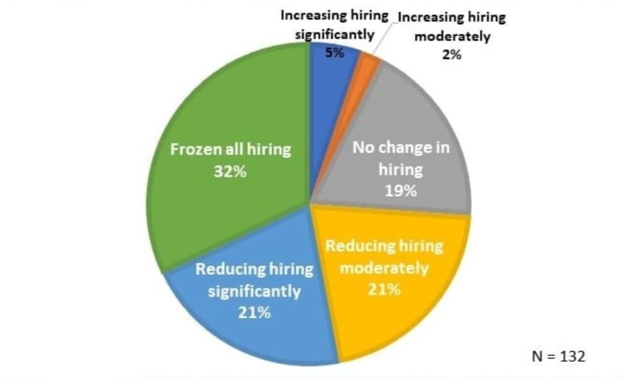

**Q2. Post- Coronavirus Recruiting and Hiring Plan?**

**a. Yes.**

**b. No.**

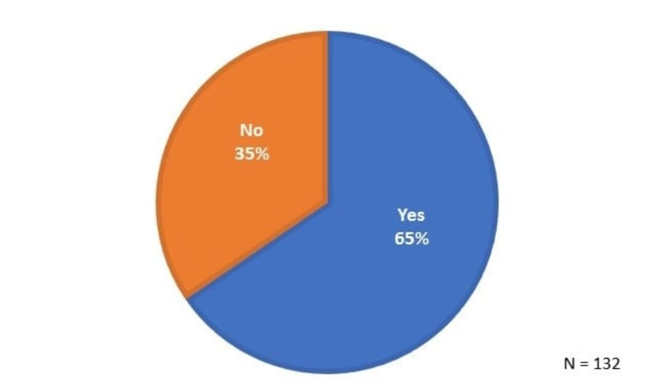

**Q3. Are you Laying Off and / or Furloughing Employees?**

**a. We’re thinking about it.**

**b. Yes.**

**c. No.**

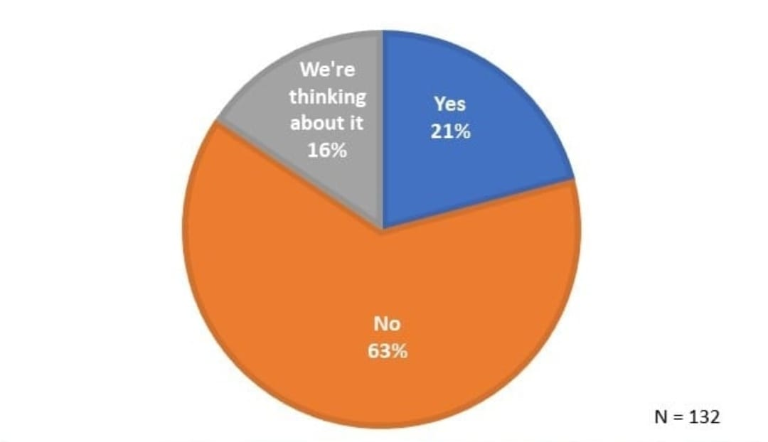

**Q4. Coronavirus (COVID-19) Statement on Recruitment Drive?**

**a. We’re working on it.**

**b. We’re thinking about it.**

**c. Yes.**

**d. No.**

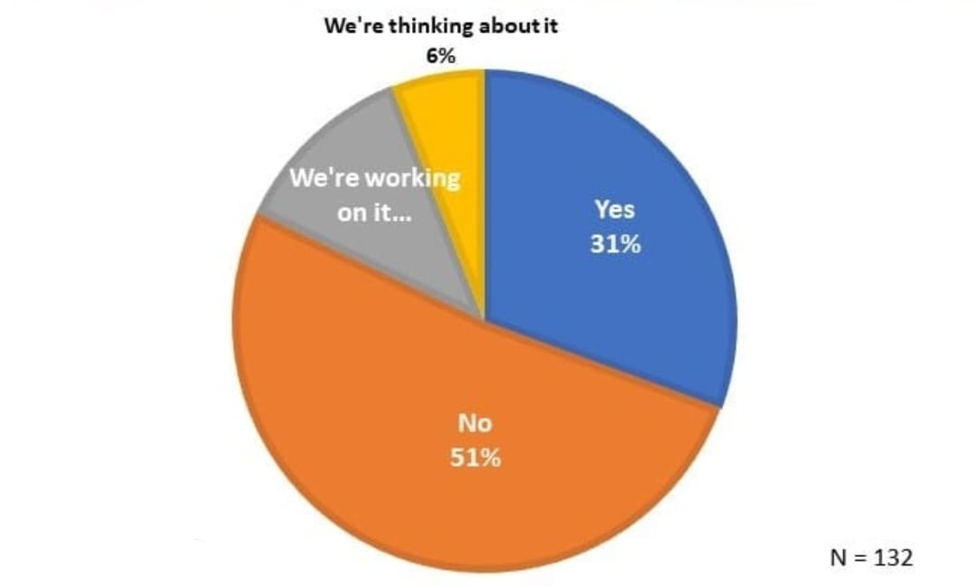

**Q5. Communications Plan for Candidates / Employees?**

**a. We’re thinking about it.**

**b. We’re working on it.**

**c. Yes.**

**d. No.**

